TDD using JUnit5 and Mockito

**Candidate Name: Samarth Chourey  
Superset ID: 6394625**

1. **JUNIT Hands-On Exercises**

**Exercise 1: Setting Up JUnit**

**Scenario:**

You need to set up JUnit in your Java project to start writing unit tests.

**Steps:**

1. Create a new Java project in your IDE (e.g., IntelliJ IDEA, Eclipse).

2. Add JUnit dependency to your project. If you are using Maven, add the following to your

pom.xml:

<dependency>

<groupId>junit</groupId>

<artifactId>junit</artifactId>

<version>4.13.2</version>

<scope>test</scope>

</dependency>

1. Create a new test class in your project.

**Solution Checklist**

1. Java project created in IDE (IntelliJ/VSCode)
2. pom.xml includes:

<dependency>

<groupId>junit</groupId>

<artifactId>junit</artifactId>

<version>4.13.2</version>

<scope>test</scope>

</dependency>

1. Maven project refreshed and JUnit downloaded
2. Test class created in src/test/java
3. Test method added with @Test annotation
4. Test runs successfully (command: mvn test)

**POM.xml:**

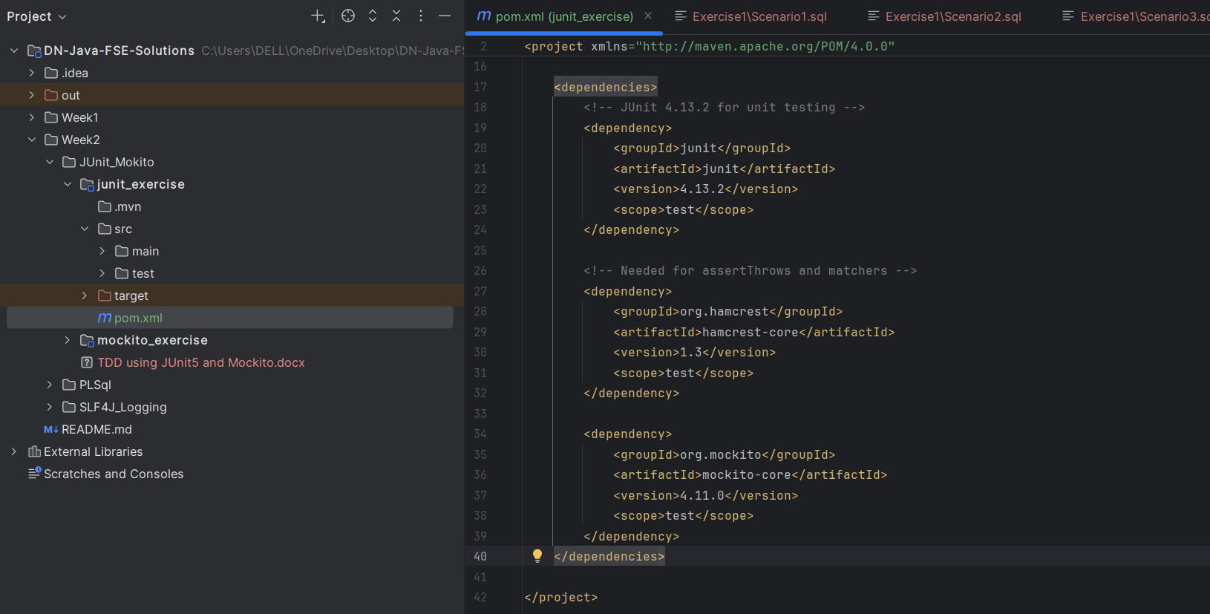

**OUTPUT:**

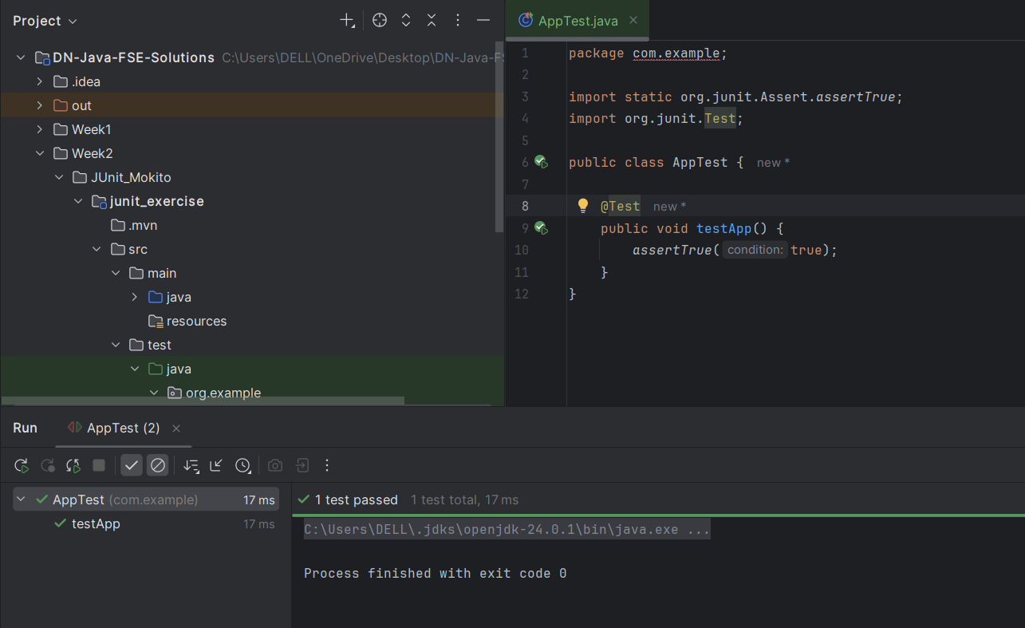

**Exercise 3: Assertions in JUnit**

**Scenario:**

You need to use different assertions in JUnit to validate your test results.

**Steps:**

1. Write tests using various JUnit assertions.

**Solution Code:**

public class **AssertionsTest** {

@Test

public void **testAssertions**() {

// Assert equals

**assertEquals**(5, 2 + 3);

// Assert true

**assertTrue**(5 > 3);

// Assert false

**assertFalse**(5 < 3);

// Assert null

**assertNull**(null);

// Assert not null

**assertNotNull**(new Object());

}

}

**SOLUTION CHECKLIST**

1. Test class **AssertionsTest.java** created
2. Test method **testAssertions**() added with **@Test** annotation
3. Following JUnit assertions implemented inside the test method:

**assertEquals**(5, 2 + 3);

**assertTrue**(5 > 3);

**assertFalse**(5 < 3);

**assertNull**(null);

**assertNotNull**(new **Object**());

1. Required imports added:

import org.junit.Test;

import static org.junit.Assert.*;

1. Test executed using **mvn test** and ran successfully

**OUTPUT**

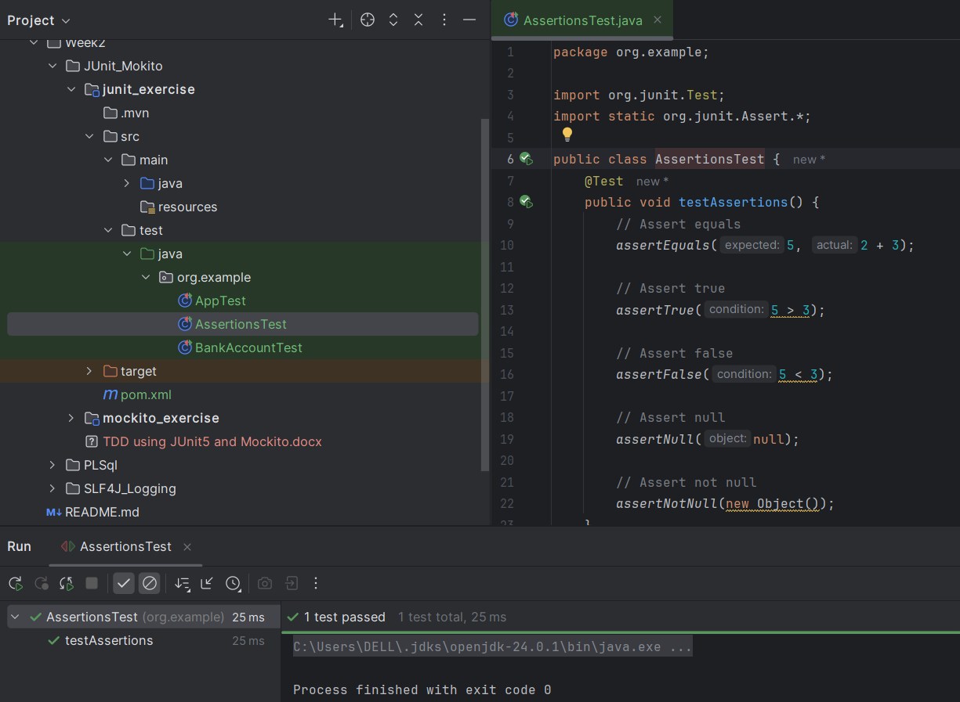

**Exercise 4: Arrange-Act-Assert (AAA) Pattern, Test Fixtures, Setup and Teardown Methods in JUnit**

**Scenario:**

You need to organize your tests using the Arrange-Act-Assert (AAA) pattern and use setup and teardown methods.

**Steps:**

1. Write tests using the AAA pattern.

2. Use **@Before** and **@After** annotations for setup and teardown methods.

**SOLUTION CHECKLIST**

1. Class BankAccount created under **src/main/java/org/example** with the following:

Constructor accepting initial balance

**deposit**(double **amount**) method

**withdraw**(double **amount**) method with check for sufficient funds

**getBalance**() method to return current balance

1. Test class **BankAccountTest** created under **src/test/java/org/example**
2. Used **Arrange-Act-Assert** (AAA) pattern in all test methods:

**testDeposit**() tests deposit functionality

**testWithdraw**() tests withdrawal within available balance

**testWithdrawMoreThanBalance**() tests prevention of overdrawing

1. Setup and Teardown methods implemented:

**@Before setUp**() initializes a fresh BankAccount object before each test

**@After tearDown**() cleans up by setting the object to null

1. Included print statements ("Setup" and "Teardown") to verify execution flow
2. Required imports added:

import org.junit.Before;

import org.junit.After;

import org.junit.Test;

import static org.junit.Assert.assertEquals;

1. Tests executed using **mvn test** and passed successfully

**OUTPUT**

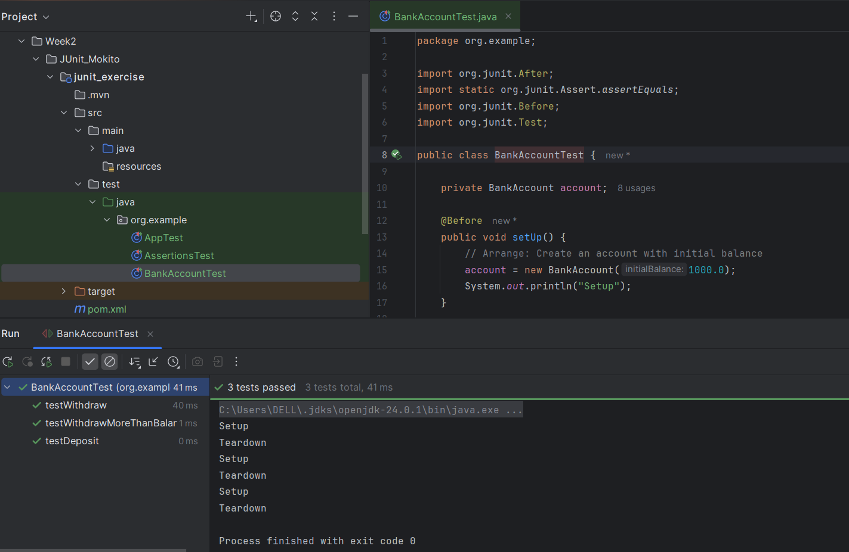

1. **Mockito Hands-On Exercises**

**Exercise 1: Mocking and Stubbing**

**Scenario:**

You need to test a service that depends on an external API. Use Mockito to mock the external API and stub its methods.

**Steps:**

1. Create a mock object for the external API.
2. Stub the methods to return predefined values.
3. Write a test case that uses the mock object.

**Solution Code:**

package org.example;  
  
public class Service {  
  
 private final ExternalApi externalApi;  
  
 public Service(ExternalApi externalApi) {  
 this.externalApi = externalApi;  
 }  
  
 public String fetchData() {  
 return externalApi.getData();  
 }  
}

**Exercise 2: Verifying Interactions**

**Scenario:**

You need to ensure that a method is called with specific arguments.

**Steps:**

1. Create a mock object.
2. Call the method with specific arguments.
3. Verify the interaction.

**Solution Code:**

package org.example;  
  
import org.junit.Test;  
import static org.junit.Assert.*assertEquals*;  
import static org.mockito.Mockito.*;  
  
public class ServiceTest {  
 @Test  
 public void testExternalApi() {  
 // Step 1: Create a mock of ExternalApi  
 ExternalApi mockApi = *mock*(ExternalApi.class);  
  
 // Step 2: Stub getData() to return a fake value  
 *when*(mockApi.getData()).thenReturn("Mock Data");  
  
 // Step 3: Inject mock into MyService  
 Service service = new Service(mockApi);  
  
 // Step 4: Call method under test  
 String result = service.fetchData();  
  
 // Step 5: Assert the result  
 *assertEquals*("Mock Data", result);  
  
 // Optional: Verify the interaction  
 *verify*(mockApi).getData();  
 }  
}

**SOLUTION CHECKLIST (COMBINED EX_1 & EX_2)**

1. Interface/class ExternalApi created with a method getData()
2. Class Service implemented with:
   1. Constructor that accepts an ExternalApi instance
   2. Method **fetchData**() that calls **externalApi.getData**()
3. Test class **ServiceTest** created under **src/test/java/org/example**

🧪 Exercise 1: **Mocking and Stubbing**

1. In **testExternalApi**():
   1. Created mock object using **Mockito.mock**(ExternalApi.class)
   2. Stubbed **getData**() to return "Mock Data" using **when**(...).**thenReturn**(...)
   3. Created a **Service** instance using the mock Called **fetchData**() and asserted result with:

**assertEquals**("Mock Data", result);

🧪 Exercise 2: **Verifying Interactions**

1. In **testVerifyInteraction**():
   1. Created mock object of **ExternalApi**
   2. Passed it to **Service** and called **fetchData**()
   3. Verified interaction using:
      1. **verify**(mockApi).getData();
2. Required imports added:

import static org.mockito.Mockito.*;

import static org.junit.Assert.assertEquals;

import org.junit.Test;

1. Tests executed using mvn test and passed successfully

**OUTPUT**

